Making AccountChek® Your Own

Thank you for choosing AccountChek® by FormFree®, the industry’s most trusted source for safe and simple verification of borrower assets, income and employment.

We are pleased to offer optional white labeling of the entire borrower process – the communications we send to your borrowers as part of the AccountChek verification process, as well as the borrower web portal.

What It Means

If you choose to turn on the white-labeling feature, we will brand the emails we send to your borrowers with your company’s name and logo instead of our own and replace the AccountChek logo in the borrower web portal with your company’s logo. If requested, we can also add custom content to the emails.

What We Need from You

To enable white-labeling, send the following items to customersuccess@formfree.com using subject line “White-Labeling Request”:

- Your high-resolution logo in .png or .ai format (required)

- Any requests to customize the content on the Welcome Email or Lost Credentials Email (optional: see examples below)

What Happens Next?

Please allow one week from the time you send your white-labeling request for the FormFree team to implement your changes. You will be notified once white-labeling process is complete. After that, your logo and requested customizations will appear in the emails AccountChek sends to your borrowers, and all of your borrowers logging into the AccountChek Borrower portal will see your logo as well.

Copyright© 2017 FormFree Holdings Corporation. All rights reserved.

AccountChek® and the AccountChek logo are registered trademarks of FormFree Holdings Corporation.

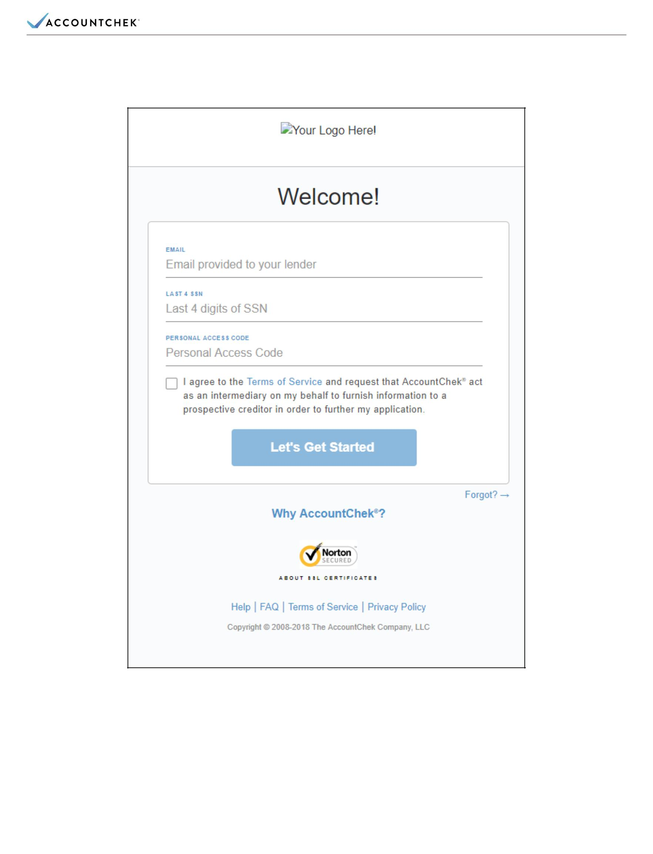
BORROWER PORTAL SAMPLE

Copyright© 2017 FormFree Holdings Corporation. All rights reserved.

AccountChek® and the AccountChek logo are registered trademarks of FormFree Holdings Corporation.

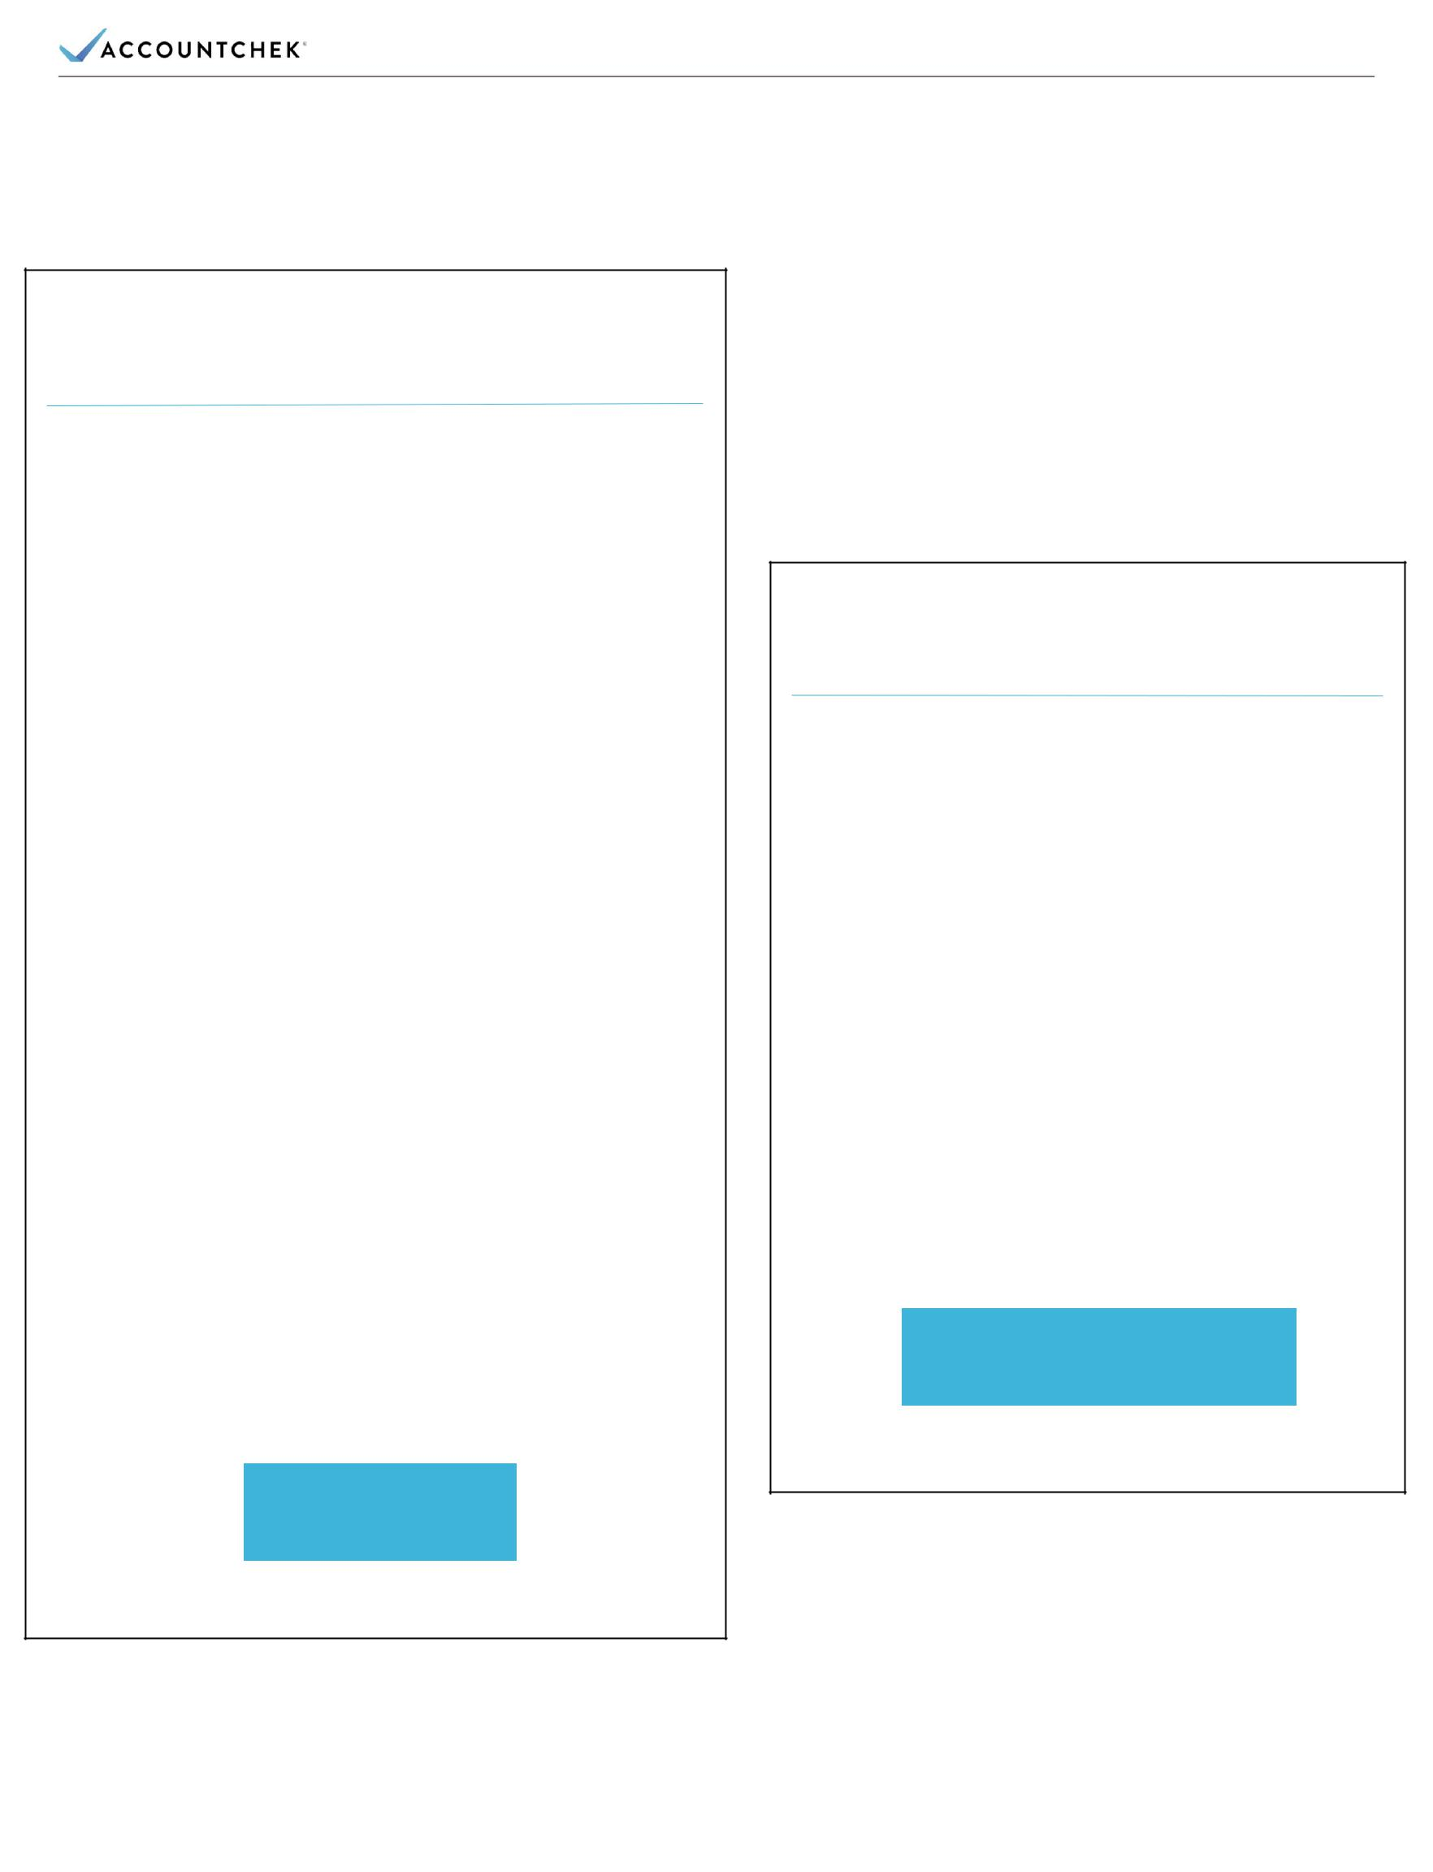
WELCOME EMAIL SAMPLE

[YOUR LOGO HERE]

Hi, Bobby Borrower,

Thank you for choosing [YOUR COMPANY NAME] for your mortgage loan. Your loan application is almost done. The next step is to verify your assets.

At, [YOUR COMPANY NAME] we’re dedicated to making your loan process efficient and user-friendly, which is why we use AccountChek® by FormFree® as our third-party asset verification service.

AccountChek is the new standard in loan verification security. It streamlines asset verification with a paperless process that is easy and safe.

To get started, have your login credentials handy for any checking, savings, retirement or investment accounts relevant to securing your loan. Then click the button below, and AccountChek will guide you through the process, which will only take a few minutes.

Feel free to reach out to me or any other mortgage representative at [YOUR COMPANY NAME] if you have questions or concerns.

Thank you, and have a great day.

[YOUR NAME]

[YOUR COMPANY NAME]

GET STARTED

RE-VERIFY CREDENTIALS

EMAIL SAMPLE

[YOUR LOGO HERE]

Hi, Bobby Borrower,

AccountChek is unable to update your account information for your loan with

[YOUR COMPANY NAME]. Please have your login credentials handy and click below to follow the steps to ensure your information is accurate.

If your loan is closed, please contact your loan officer at [YOUR COMPANY NAME] to close your order.

Thank you,

[YOUR NAME]

[YOUR COMPANY NAME]

RE-VERIFY CREDENTIALS

Copyright© 2017 FormFree Holdings Corporation. All rights reserved.

AccountChek® and the AccountChek logo are registered trademarks of FormFree Holdings Corporation.

HOW TO REQUEST CUSTOME CONTENT (OPTIONAL)

If you would like to request customization of the content sent to borrowers, please mark your changes to the email content below in red or by using Microsoft Word’s “track changes” feature. Requested customizations are subject to review by the FormFree team.

Welcome Email | Hi, [$BorrowerFirstNameLastName$],  Thank you for choosing [$VerifierCompanyName$] for your mortgage loan. Your loan application is almost done. The next step is to verify your assets.  At [$VerifierCompanyName$], we’re dedicated to making your loan process efficient and user-friendly, which is why we use AccountChek by FormFree as our third-party asset verification service.  AccountChek is the new standard in loan verification security. It streamlines asset verification with a paperless process that is easy and safe.  To get started, have your login credentials handy for any checking, savings, retirement or investment accounts relevant to securing your loan. Then click the button below, and AccountChek will guide you through the process, which will only take a few minutes.  Feel free to reach out to me or any other mortgage representative at [$VerifierCompanyName$] if you have questions or concerns.  Thank you and have a great day.  [$Verifier Name$]  {$VerifierCompanyName$]
Re-enter Credentials Email | Hi, [$BorrowerFirstNameLastName$],  AccountChek is unable to update your account information for your loan with [$VerifierCompanyName$]. Please have your login credentials handy and click below to follow the steps to ensure your information is accurate.  If your loan is closed, please contact your loan officer at [$VerifierCompanyName$] to close your order.  Thank you,  [$VerifierName$]  [$VerifierCompanyName$]

Copyright© 2017 FormFree Holdings Corporation. All rights reserved.

AccountChek® and the AccountChek logo are registered trademarks of FormFree Holdings Corporation.

